Introduction
This write-up refers to the WASPS machine. If you require support, please open a ticket in the support channel on the Discord server.

Reconnaissance
The initial enumeration of the challenge was started with the objective of identifying open ports on the target machine.

nmap -p- --open -min-rate 1200 <MACHINE-IP> -sVC -vvv

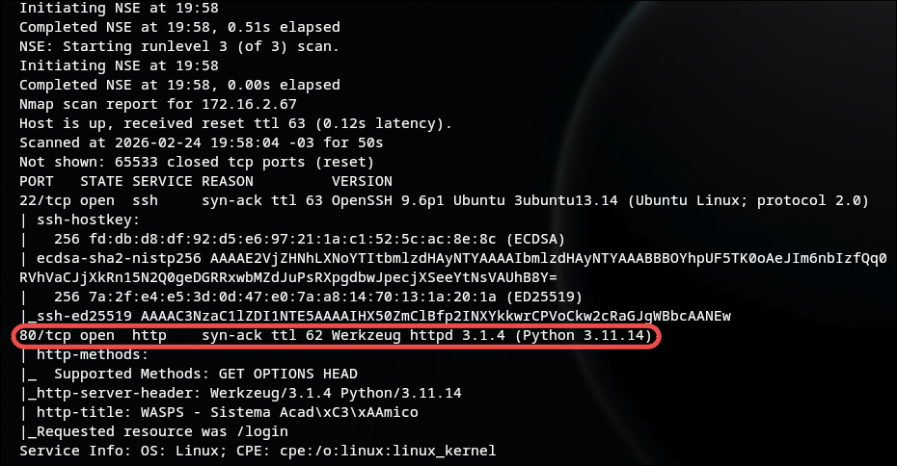

From the Nmap output, a Python server running on port 80 was identified. When accessing the web application, it was possible to identify an academic management system.

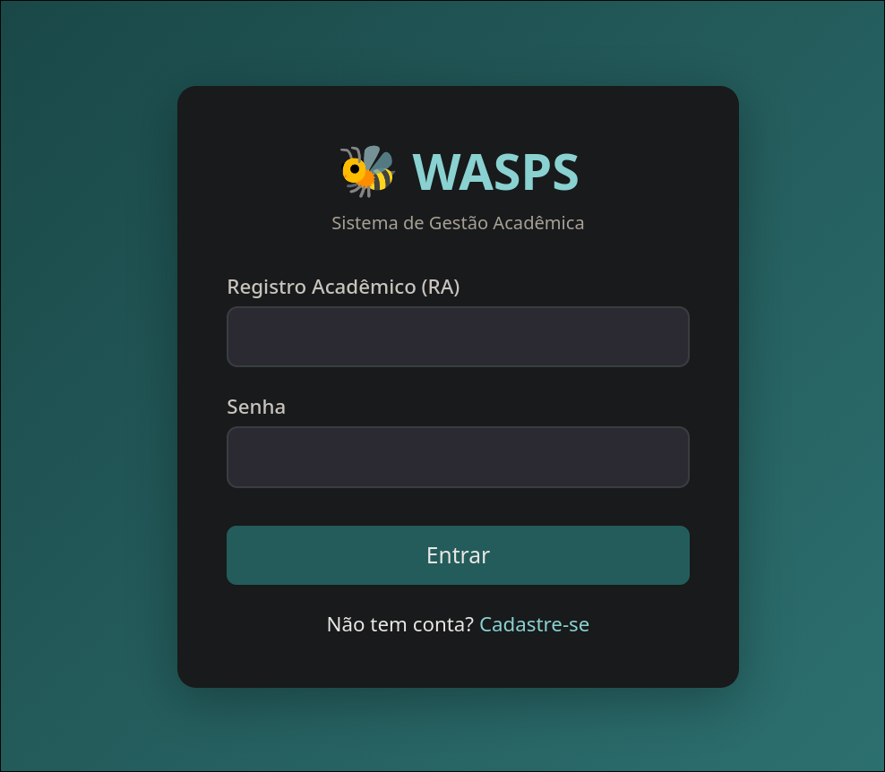

In addition to the target environment, the source code of the web application was also provided together with the challenge. The source code was extracted for analysis of the available files.

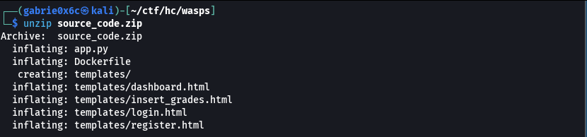
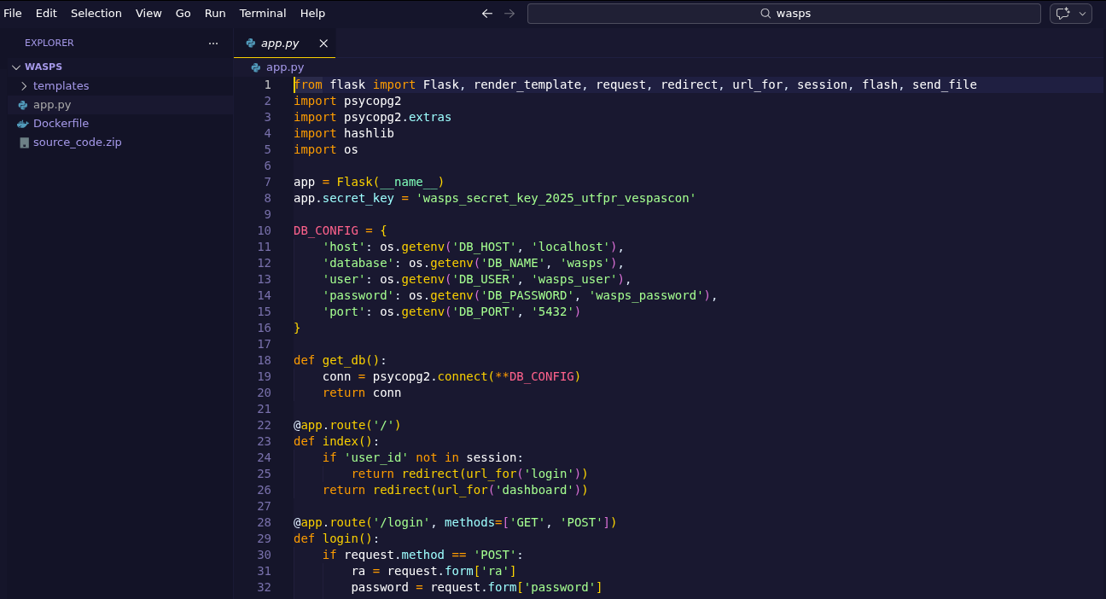
The web application is developed in Python. Among the available routes, the endpoint /backup.zip stands out, which allows downloading a backup file.
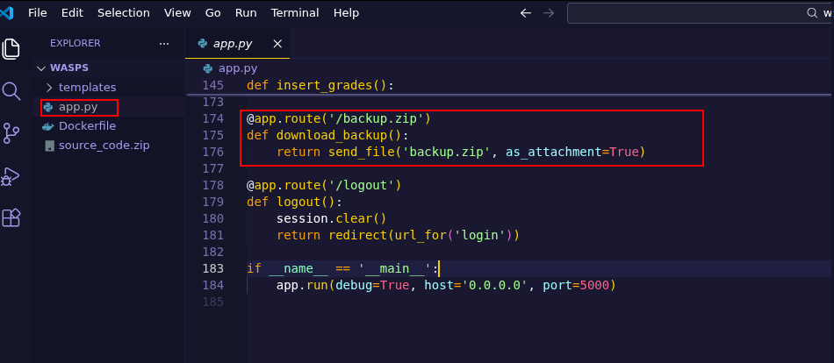

The route /backup.zip was accessed, allowing the download of the backup file.

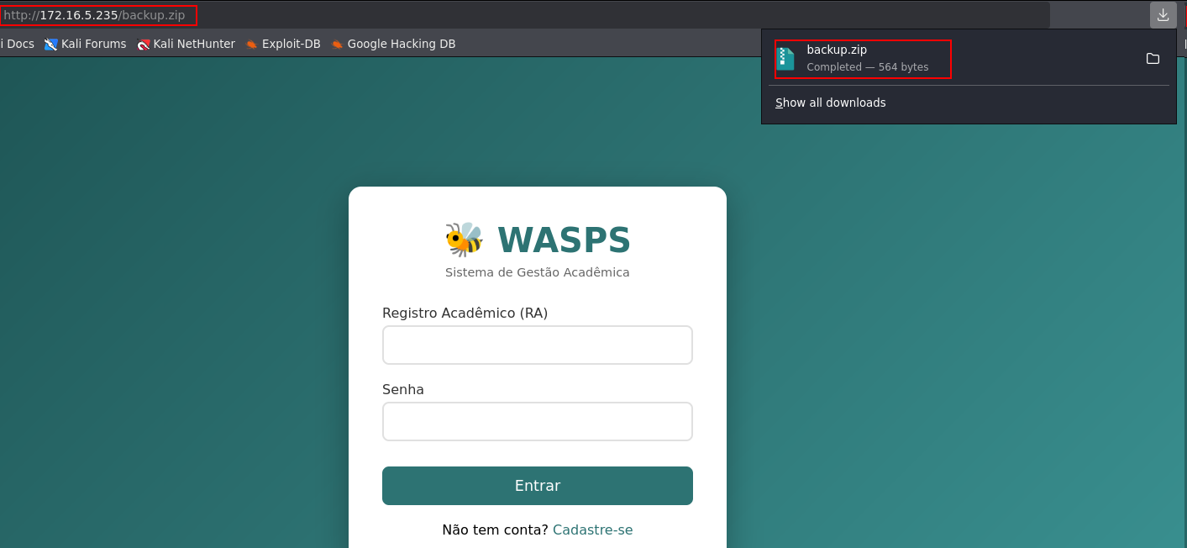

After extracting its contents, valid user credentials were identified.

unzip backup.zip

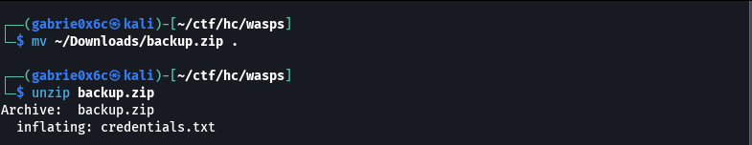

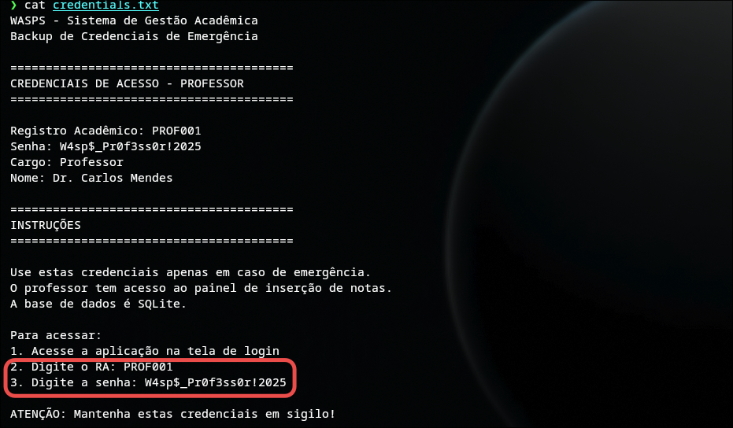

Using the obtained credentials, it was possible to authenticate and gain access to the web application.

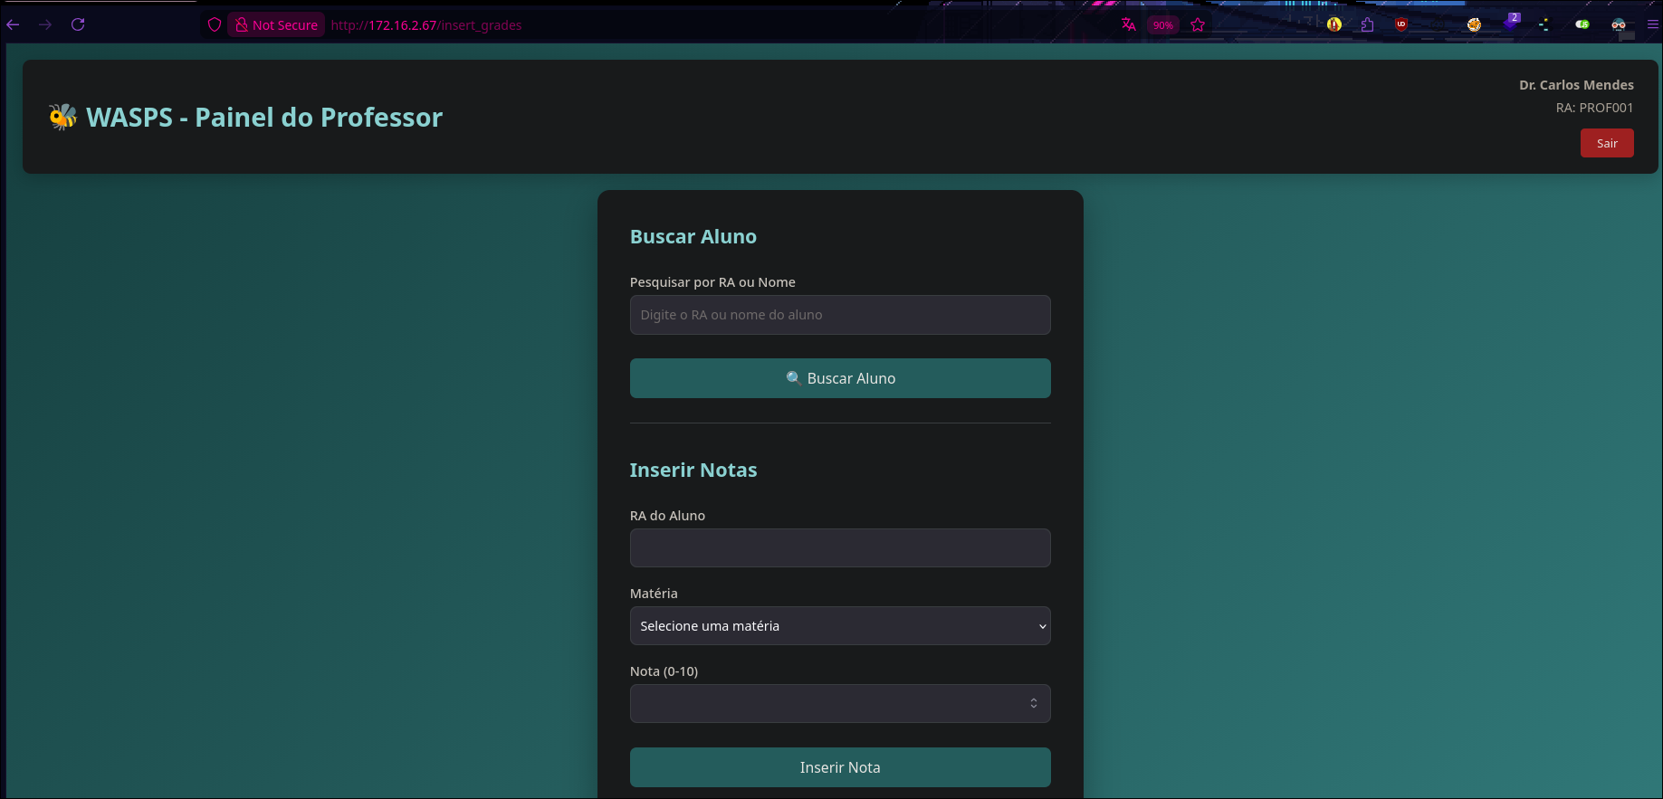

With valid credentials, it was possible to access the dashboard, which provides functionalities such as searching for students by name and entering grades.

On the /search_student route, an SQL Injection vulnerability was identified. The parameter supplied by the user was concatenated directly into the SQL query, without any sanitization or use of prepared statements.

This implementation allowed the injection of arbitrary queries into the database, enabling manipulation and extraction of information.

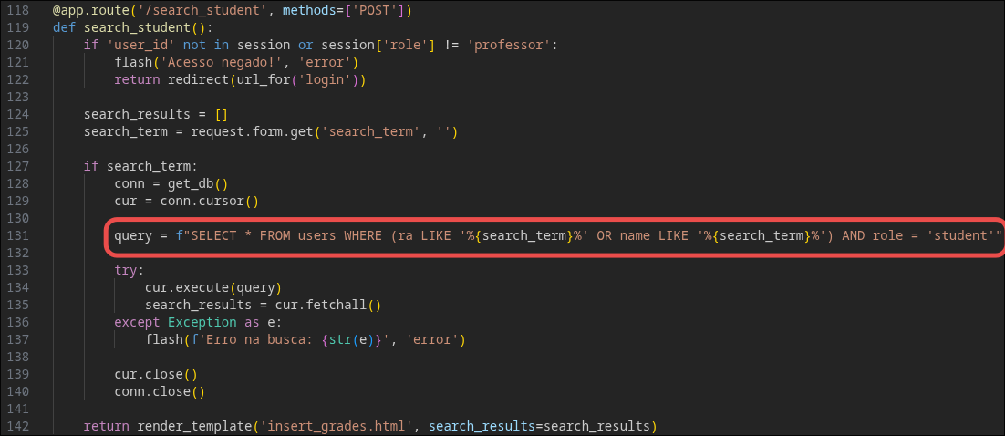

In the application, the proof of concept was confirmed by inserting a single quote (') character, which resulted in the SQL query breaking. This behavior confirmed that the field was vulnerable to SQL Injection.

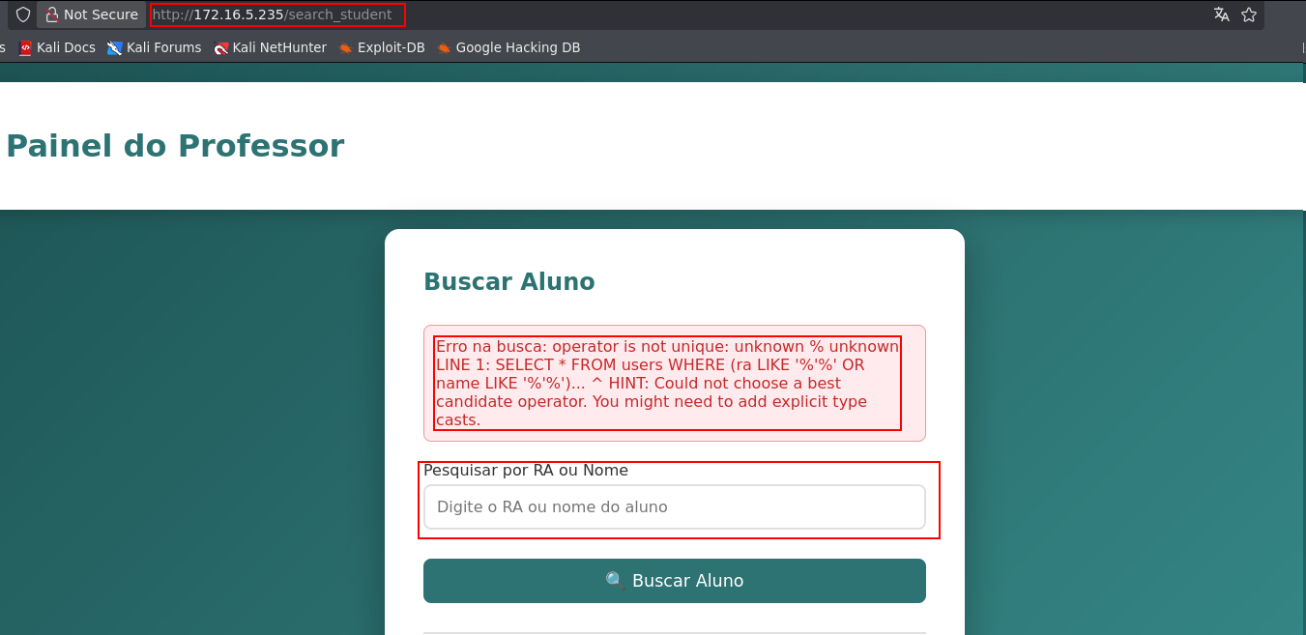

The first step to extract information was to identify the number of columns returned by the query. For this, the ORDER BY clause was used, allowing the determination of the existing number of columns.

%') order by 1-- -

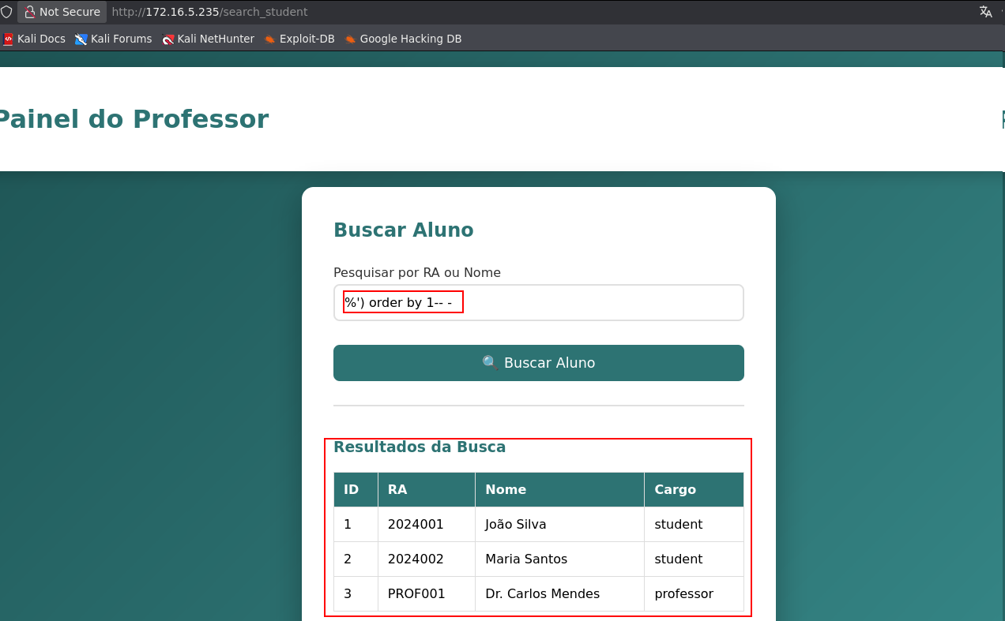

With this, it was possible to numerically identify the quantity of columns existing in the query, incrementing the value until the query returned an error.
The error occurred when trying to order by index 6. This behavior indicated that the query has 5 valid columns in the result.

%') order by 1,2,3,4,5,6-- -

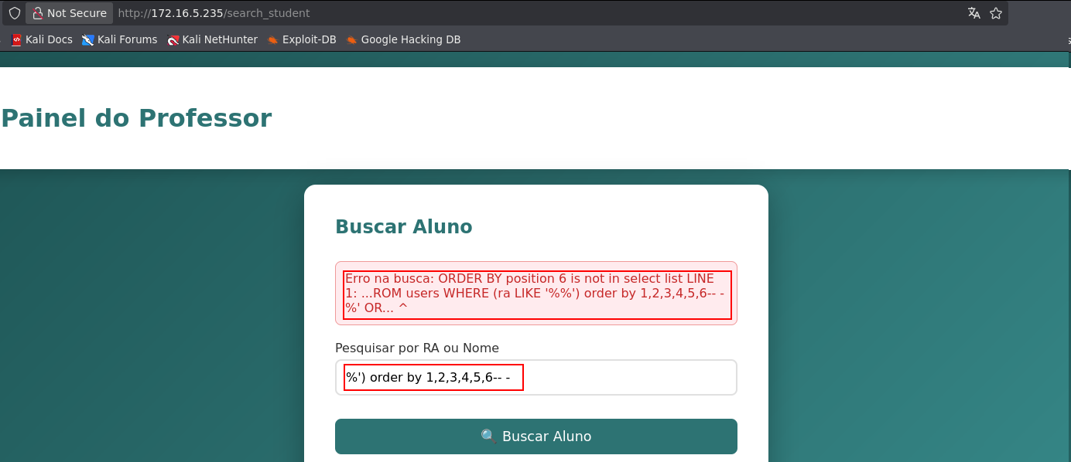

Using the standard database information_schema, it was possible to enumerate all available databases in the application. pg_toast, information_schema, public, and pg_catalog were identified.

%') union select null,schema_name,null,null,null from information_schema.schemata-- -

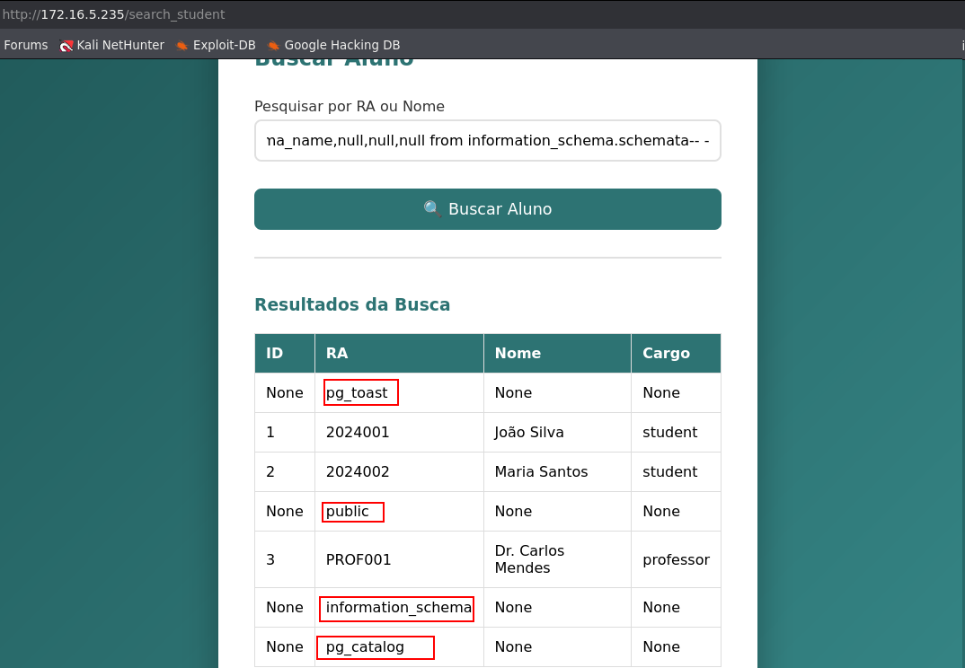

Therefore, using information_schema.tables, it was possible to list all tables in the public database.

%') UNION SELECT NULL, table_name, 'tabela', NULL, NULL FROM information_schema.tables, users WHERE table_schema='public' AND ('1'='1

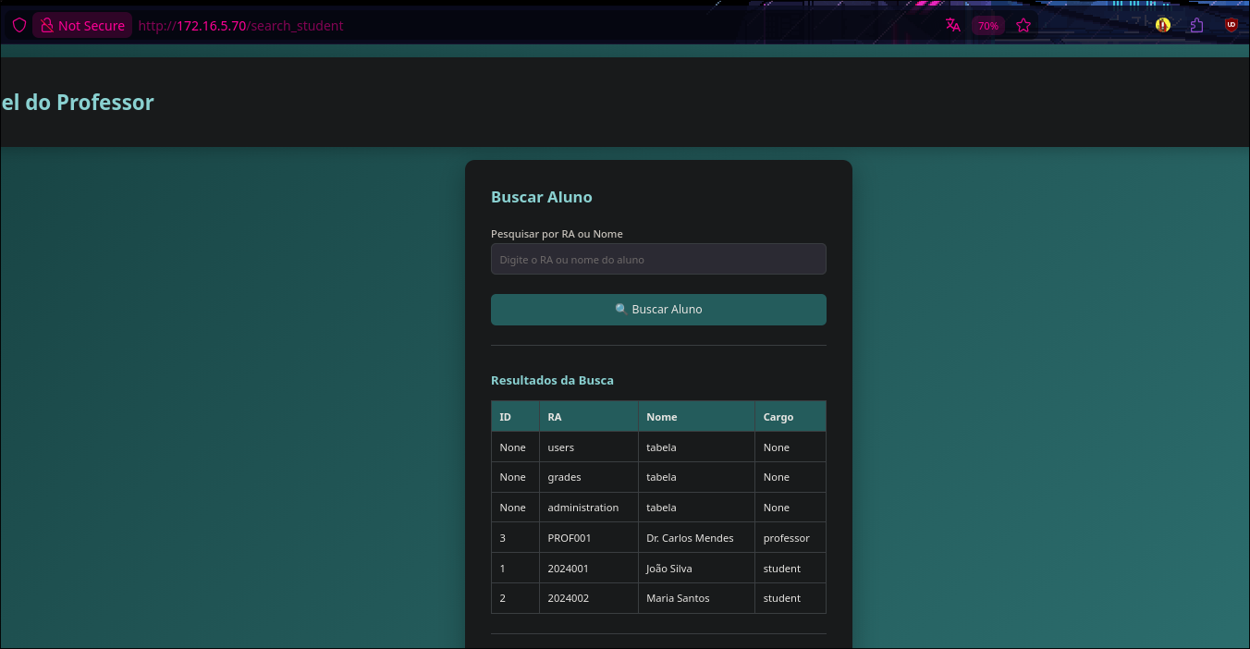

As a result, three tables were identified: users, grades, and administration. With the administration table identified, the next step was to list its columns using information_schema.columns.

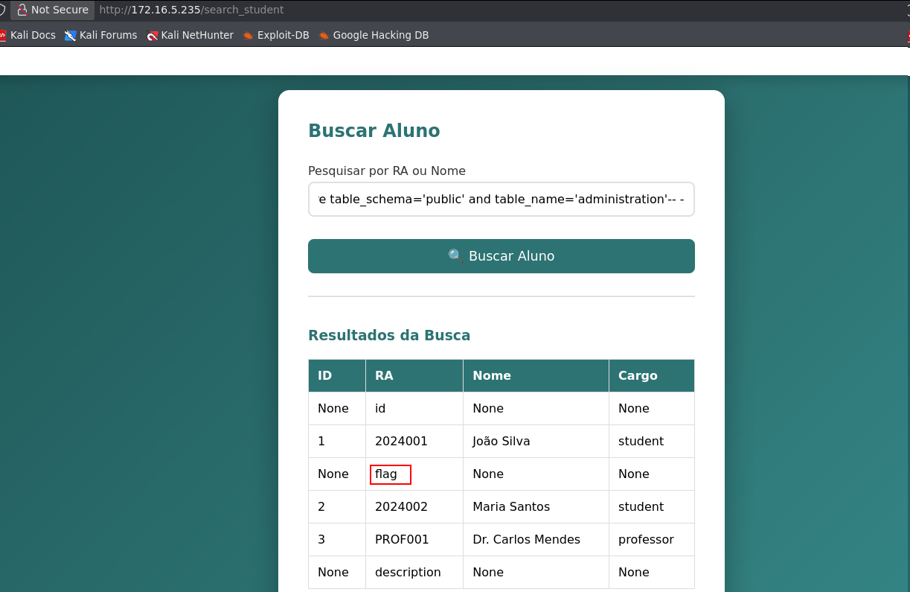

The result revealed three columns: id, description, and flag. The presence of the flag column indicated that this was the table of interest and that the challenge flag was stored in it.
With this confirmation, a specific payload was used to perform the flag extraction..

%') UNION SELECT NULL, flag, description, administration.id::text, NULL FROM administration, users WHERE ('1'='1

